IMPLEMENT K – MEANS CLUSTERING

AIM
To implement the K-Means Clustering algorithm using Python to group students based on their hours studied and marks, and visualize the clusters and their centroids using a scatter plot.

ALGORITHM:
- Import the required libraries: Pandas, Matplotlib, and Scikit-learn.
- Load the dataset from the data.csv file.
- Select Hours_Studied and Marks as input features.
- Create a K-Means clustering model with three clusters (\(K = 3\)).
- Fit the model to the selected dataset.
- Obtain the cluster labels for each data point.
- Add the cluster labels to the dataset and display the clustered data.
- Plot the data points using different colors to represent the clusters.
- Plot the cluster centroids using red X markers.
- Add axis labels, a title, and a legend to the graph.
- Display the final K-Means Clustering graph.
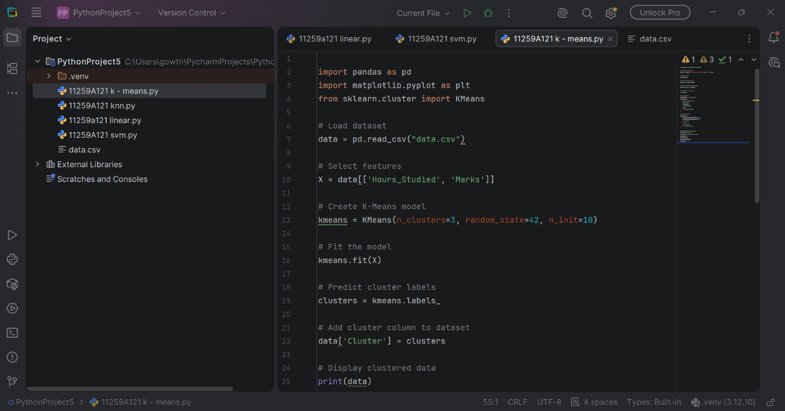
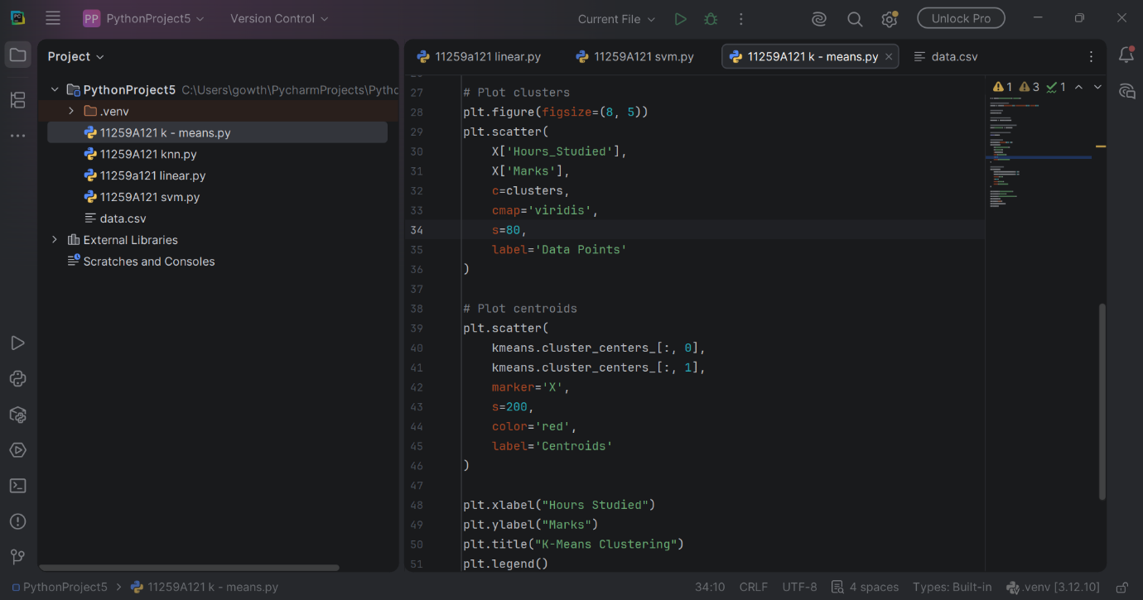
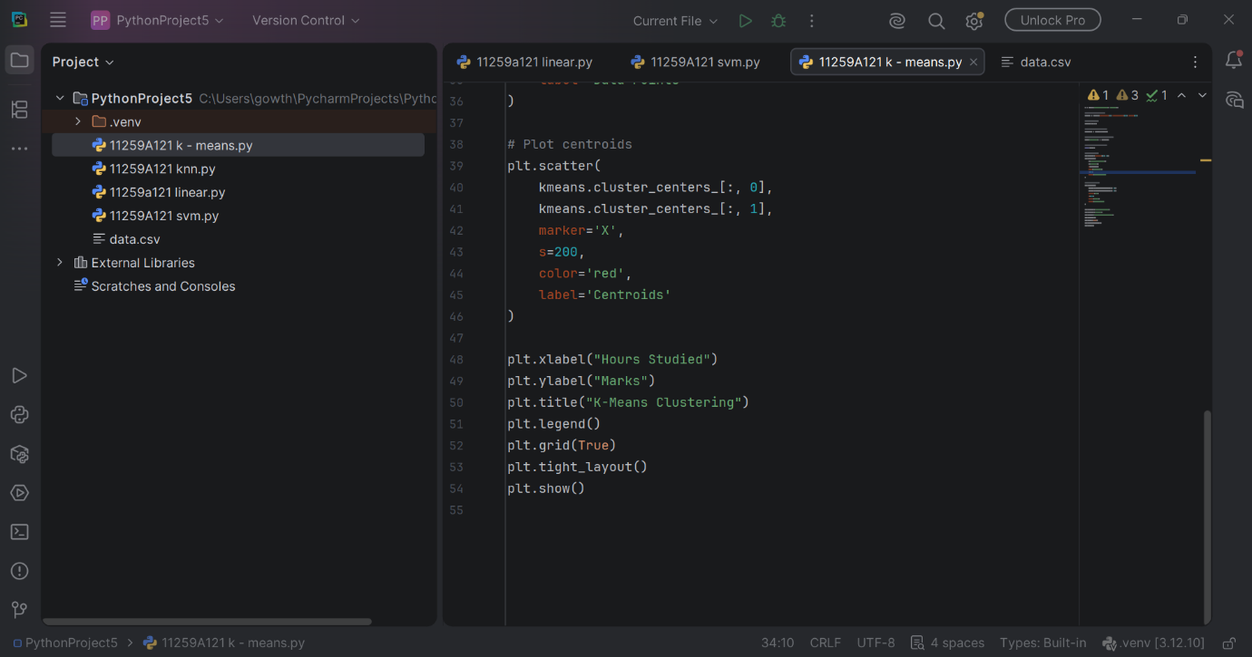
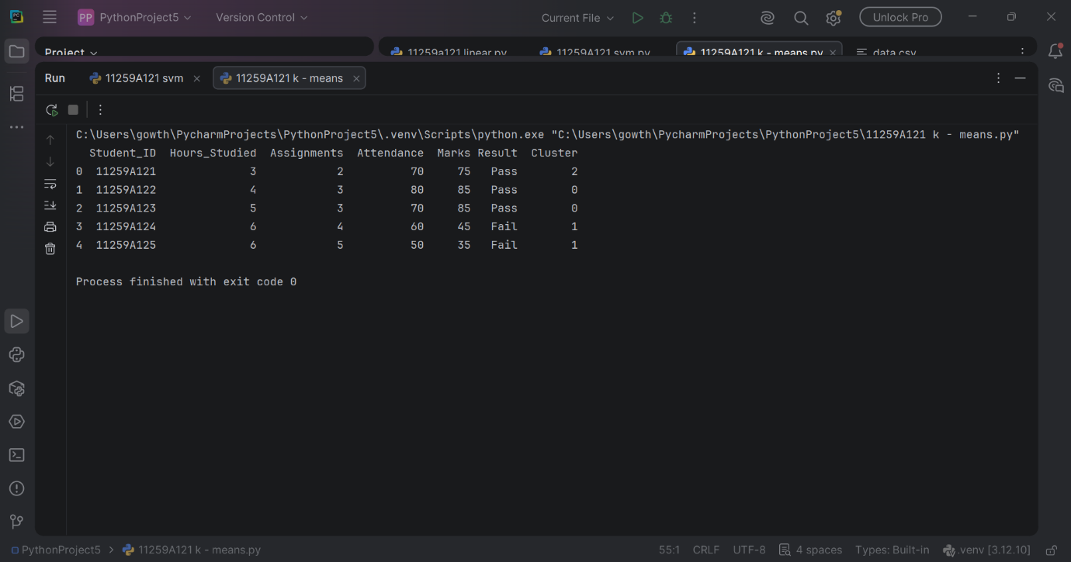
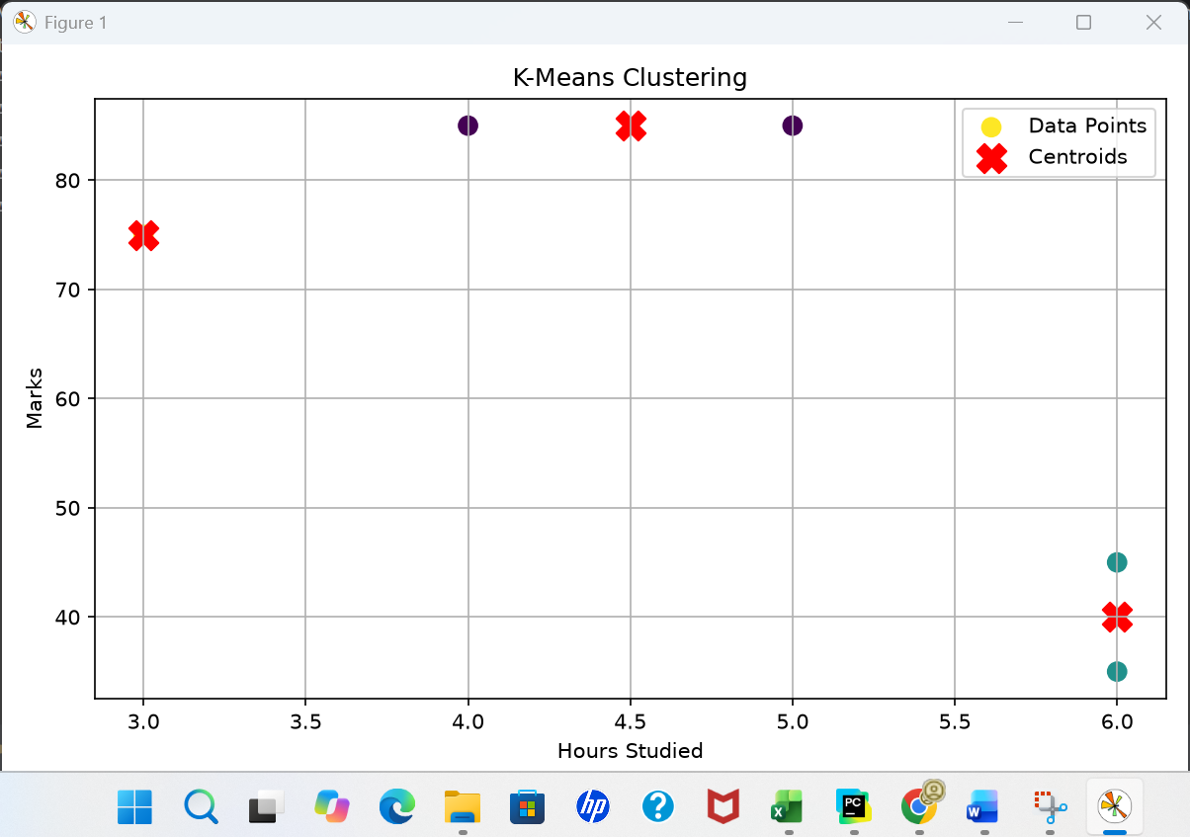

RESULT:
Thus, the K-Means Clustering algorithm was successfully implemented using Python to group students based on hours studied and marks. The resulting clusters and their centroids were displayed using a scatter plot.

